Supplementary Materials

Joel Larwood

10/06/2019

library(TOSTER)

Here we present the Two One Sided Tests for the non-significant correlations reported between alexithymia and recall emotion lexicon. The interested reader may refer to Lakens, Scheel, and Isager (2018) for the details of this method.

TOSTER::powerTOSTr(alpha = .05, statistical_power = .8, N = 162)

## The equivalence bounds to achieve 80 % power with N = 162 are -0.23 and 0.23 .

##

## [1] -0.2280002 0.2280002

low <- -.2280002  
high <- 0.2280002

#### Relationship between total alexithymia scores and total emotion words listed

#total emotions  
TOSTER::TOSTr(n = 162, r = -.05, low_eqbound_r = low, high_eqbound_r = high)

## TOST results:  
## p-value lower bound: 0.011  
## p-value upper bound: 0.0002  
##   
## Equivalence bounds (r):  
## low eqbound: -0.228   
## high eqbound: 0.228  
##   
## TOST confidence interval:  
## lower bound 90% CI: -0.179  
## upper bound 90% CI: 0.08  
##   
## NHST confidence interval:  
## lower bound 95% CI: -0.203  
## upper bound 95% CI: 0.105  
##   
## Equivalence Test Result:  
## The equivalence test was significant, p = 0.0109, given equivalence bounds of -0.228 and 0.228 and an alpha of 0.05.

##

##   
## Null Hypothesis Test Result:  
## The null hypothesis test was non-significant, p = 0.527, given an alpha of 0.05.

##

##   
## Based on the equivalence test and the null-hypothesis test combined, we can conclude that the observed effect is statistically not different from zero and statistically equivalent to zero.

##

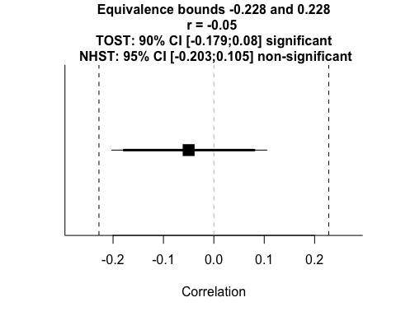

#### Relationship between total alexithymia scores and total positive emotion words listed

#positive emotions   
TOSTER::TOSTr(n = 162, r = -.13, low_eqbound_r = low, high_eqbound_r = high)

## TOST results:  
## p-value lower bound: 0.101  
## p-value upper bound: 0.000002  
##   
## Equivalence bounds (r):  
## low eqbound: -0.228   
## high eqbound: 0.228  
##   
## TOST confidence interval:  
## lower bound 90% CI: -0.255  
## upper bound 90% CI: 0  
##   
## NHST confidence interval:  
## lower bound 95% CI: -0.279  
## upper bound 95% CI: 0.025  
##   
## Equivalence Test Result:  
## The equivalence test was non-significant, p = 0.101, given equivalence bounds of -0.228 and 0.228 and an alpha of 0.05.

##

##   
## Null Hypothesis Test Result:  
## The null hypothesis test was non-significant, p = 0.0992, given an alpha of 0.05.

##

##   
## Based on the equivalence test and the null-hypothesis test combined, we can conclude that the observed effect is statistically not different from zero and statistically not equivalent to zero.

##

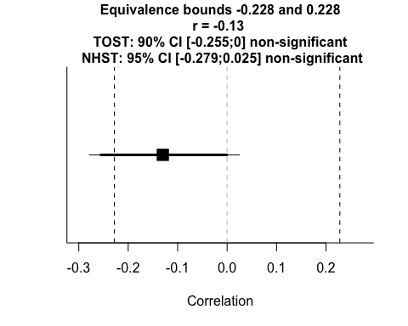

#### Relationship between total alexithymia scores and total negative emotion words listed

#negative emotions  
TOSTER::TOSTr(n = 162, r = .02, low_eqbound_r = low, high_eqbound_r = high)

## TOST results:  
## p-value lower bound: 0.0007  
## p-value upper bound: 0.004  
##   
## Equivalence bounds (r):  
## low eqbound: -0.228   
## high eqbound: 0.228  
##   
## TOST confidence interval:  
## lower bound 90% CI: -0.11  
## upper bound 90% CI: 0.149  
##   
## NHST confidence interval:  
## lower bound 95% CI: -0.135  
## upper bound 95% CI: 0.174  
##   
## Equivalence Test Result:  
## The equivalence test was significant, p = 0.00375, given equivalence bounds of -0.228 and 0.228 and an alpha of 0.05.

##

##   
## Null Hypothesis Test Result:  
## The null hypothesis test was non-significant, p = 0.801, given an alpha of 0.05.

##

##   
## Based on the equivalence test and the null-hypothesis test combined, we can conclude that the observed effect is statistically not different from zero and statistically equivalent to zero.

##

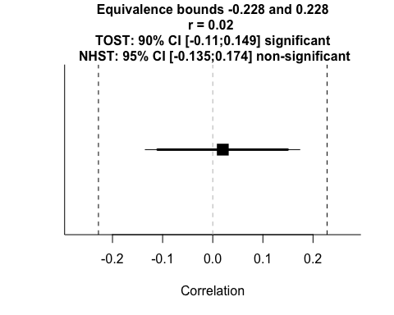

#### Relationship between Externally Oriented Thinking (EOT) and total emotion words listed

TOSTER::TOSTr(n = 162, r = .04, low_eqbound_r = low, high_eqbound_r = high)

## TOST results:  
## p-value lower bound: 0.0003  
## p-value upper bound: 0.008  
##   
## Equivalence bounds (r):  
## low eqbound: -0.228   
## high eqbound: 0.228  
##   
## TOST confidence interval:  
## lower bound 90% CI: -0.09  
## upper bound 90% CI: 0.169  
##   
## NHST confidence interval:  
## lower bound 95% CI: -0.115  
## upper bound 95% CI: 0.193  
##   
## Equivalence Test Result:  
## The equivalence test was significant, p = 0.00772, given equivalence bounds of -0.228 and 0.228 and an alpha of 0.05.

##

##   
## Null Hypothesis Test Result:  
## The null hypothesis test was non-significant, p = 0.613, given an alpha of 0.05.

##

##   
## Based on the equivalence test and the null-hypothesis test combined, we can conclude that the observed effect is statistically not different from zero and statistically equivalent to zero.

##

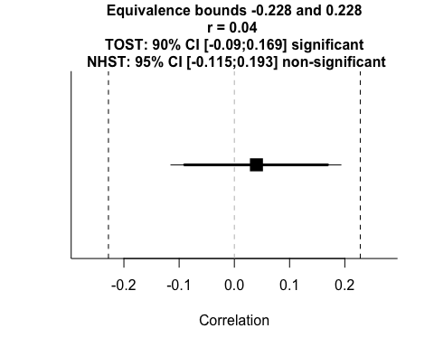

#### Relationship between Externally Oriented Thinking (EOT) and total positive emotion words listed

TOSTER::TOSTr(n = 162, r = .03, low_eqbound_r = low, high_eqbound_r = high)

## TOST results:  
## p-value lower bound: 0.0005  
## p-value upper bound: 0.005  
##   
## Equivalence bounds (r):  
## low eqbound: -0.228   
## high eqbound: 0.228  
##   
## TOST confidence interval:  
## lower bound 90% CI: -0.1  
## upper bound 90% CI: 0.159  
##   
## NHST confidence interval:  
## lower bound 95% CI: -0.125  
## upper bound 95% CI: 0.183  
##   
## Equivalence Test Result:  
## The equivalence test was significant, p = 0.00542, given equivalence bounds of -0.228 and 0.228 and an alpha of 0.05.

##

##   
## Null Hypothesis Test Result:  
## The null hypothesis test was non-significant, p = 0.705, given an alpha of 0.05.

##

##   
## Based on the equivalence test and the null-hypothesis test combined, we can conclude that the observed effect is statistically not different from zero and statistically equivalent to zero.

##

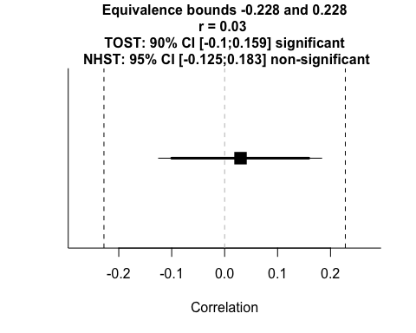

#### Relationship between Externally Oriented Thinking (EOT) and total negative emotion words listed

TOSTER::TOSTr(n = 162, r = .03, low_eqbound_r = low, high_eqbound_r = high)

## TOST results:  
## p-value lower bound: 0.0005  
## p-value upper bound: 0.005  
##   
## Equivalence bounds (r):  
## low eqbound: -0.228   
## high eqbound: 0.228  
##   
## TOST confidence interval:  
## lower bound 90% CI: -0.1  
## upper bound 90% CI: 0.159  
##   
## NHST confidence interval:  
## lower bound 95% CI: -0.125  
## upper bound 95% CI: 0.183  
##   
## Equivalence Test Result:  
## The equivalence test was significant, p = 0.00542, given equivalence bounds of -0.228 and 0.228 and an alpha of 0.05.

##

##   
## Null Hypothesis Test Result:  
## The null hypothesis test was non-significant, p = 0.705, given an alpha of 0.05.

##

##   
## Based on the equivalence test and the null-hypothesis test combined, we can conclude that the observed effect is statistically not different from zero and statistically equivalent to zero.

##



#### Relationship between Difficulty Describing Feelings (DDF) and total emotion words listed

TOSTER::TOSTr(n = 162, r = -.06, low_eqbound_r = low, high_eqbound_r = high)

## TOST results:  
## p-value lower bound: 0.015  
## p-value upper bound: 0.0001  
##   
## Equivalence bounds (r):  
## low eqbound: -0.228   
## high eqbound: 0.228  
##   
## TOST confidence interval:  
## lower bound 90% CI: -0.188  
## upper bound 90% CI: 0.07  
##   
## NHST confidence interval:  
## lower bound 95% CI: -0.212  
## upper bound 95% CI: 0.095  
##   
## Equivalence Test Result:  
## The equivalence test was significant, p = 0.015, given equivalence bounds of -0.228 and 0.228 and an alpha of 0.05.

##

##   
## Null Hypothesis Test Result:  
## The null hypothesis test was non-significant, p = 0.448, given an alpha of 0.05.

##

##   
## Based on the equivalence test and the null-hypothesis test combined, we can conclude that the observed effect is statistically not different from zero and statistically equivalent to zero.

##

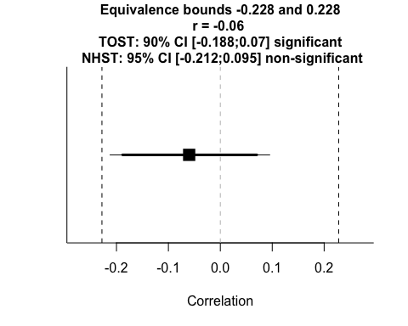

#### Relationship between Difficulty Describing Feelings (DDF) and total negative emotion words listed

TOSTER::TOSTr(n = 162, r = .05, low_eqbound_r = low, high_eqbound_r = high)

## TOST results:  
## p-value lower bound: 0.0002  
## p-value upper bound: 0.011  
##   
## Equivalence bounds (r):  
## low eqbound: -0.228   
## high eqbound: 0.228  
##   
## TOST confidence interval:  
## lower bound 90% CI: -0.08  
## upper bound 90% CI: 0.179  
##   
## NHST confidence interval:  
## lower bound 95% CI: -0.105  
## upper bound 95% CI: 0.203  
##   
## Equivalence Test Result:  
## The equivalence test was significant, p = 0.0109, given equivalence bounds of -0.228 and 0.228 and an alpha of 0.05.

##

##   
## Null Hypothesis Test Result:  
## The null hypothesis test was non-significant, p = 0.527, given an alpha of 0.05.

##

##   
## Based on the equivalence test and the null-hypothesis test combined, we can conclude that the observed effect is statistically not different from zero and statistically equivalent to zero.

##

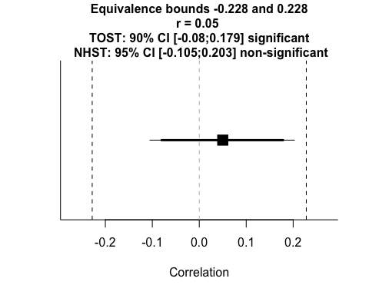

#### Relationship between Difficulty Identifying Feelings (DDF) and total emotion words listed

TOSTER::TOSTr(n = 162, r = -.08, low_eqbound_r = low, high_eqbound_r = high)

## TOST results:  
## p-value lower bound: 0.028  
## p-value upper bound: 0.00004  
##   
## Equivalence bounds (r):  
## low eqbound: -0.228   
## high eqbound: 0.228  
##   
## TOST confidence interval:  
## lower bound 90% CI: -0.208  
## upper bound 90% CI: 0.05  
##   
## NHST confidence interval:  
## lower bound 95% CI: -0.231  
## upper bound 95% CI: 0.075  
##   
## Equivalence Test Result:  
## The equivalence test was significant, p = 0.0277, given equivalence bounds of -0.228 and 0.228 and an alpha of 0.05.

##

##   
## Null Hypothesis Test Result:  
## The null hypothesis test was non-significant, p = 0.312, given an alpha of 0.05.

##

##   
## Based on the equivalence test and the null-hypothesis test combined, we can conclude that the observed effect is statistically not different from zero and statistically equivalent to zero.

##

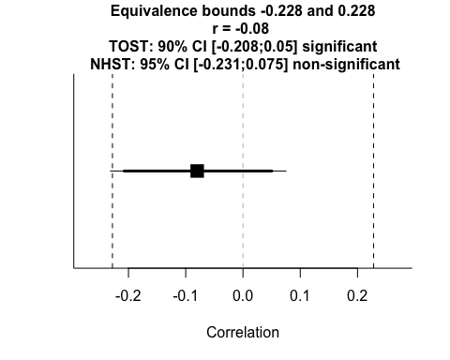

#### Relationship between Difficulty Identifying Feelings (DDF) and total positive emotion words listed

TOSTER::TOSTr(n = 162, r = -.13, low_eqbound_r = low, high_eqbound_r = high)

## TOST results:  
## p-value lower bound: 0.101  
## p-value upper bound: 0.000002  
##   
## Equivalence bounds (r):  
## low eqbound: -0.228   
## high eqbound: 0.228  
##   
## TOST confidence interval:  
## lower bound 90% CI: -0.255  
## upper bound 90% CI: 0  
##   
## NHST confidence interval:  
## lower bound 95% CI: -0.279  
## upper bound 95% CI: 0.025  
##   
## Equivalence Test Result:  
## The equivalence test was non-significant, p = 0.101, given equivalence bounds of -0.228 and 0.228 and an alpha of 0.05.

##

##   
## Null Hypothesis Test Result:  
## The null hypothesis test was non-significant, p = 0.0992, given an alpha of 0.05.

##

##   
## Based on the equivalence test and the null-hypothesis test combined, we can conclude that the observed effect is statistically not different from zero and statistically not equivalent to zero.

##



#### Relationship between Difficulty Identifying Feelings (DDF) and total negative emotion words listed

TOSTER::TOSTr(n = 162, r = -.02, low_eqbound_r = low, high_eqbound_r = high)

## TOST results:  
## p-value lower bound: 0.004  
## p-value upper bound: 0.0007  
##   
## Equivalence bounds (r):  
## low eqbound: -0.228   
## high eqbound: 0.228  
##   
## TOST confidence interval:  
## lower bound 90% CI: -0.149  
## upper bound 90% CI: 0.11  
##   
## NHST confidence interval:  
## lower bound 95% CI: -0.174  
## upper bound 95% CI: 0.135  
##   
## Equivalence Test Result:  
## The equivalence test was significant, p = 0.00375, given equivalence bounds of -0.228 and 0.228 and an alpha of 0.05.

##

##   
## Null Hypothesis Test Result:  
## The null hypothesis test was non-significant, p = 0.801, given an alpha of 0.05.

##

##   
## Based on the equivalence test and the null-hypothesis test combined, we can conclude that the observed effect is statistically not different from zero and statistically equivalent to zero.

##

